

Contents

The Crate (Shared office Space)

Introduction:

Login Page

Welcome Page

Dashboard

Business Rules

Profile

Business Rules

Company Information:

Business Rules:

Book a Room

Business Rules

Asset Report

Business Rules

Staff

Business Rules

Asset

Business Rules

Notification

Business Rules

TV Display

Business Rules

Company

Business Rule

Accounts

Business Rule

Admin

Business Rule

# The Crate (Shared office Space)

## Introduction:

It’s a solution for the shared office space solution based in Auckland North shore location. Paying attention to the details of the working & business requirements, "the crate” has created simply a cool environment that brightens your mood and increases your productivity. The services put by” the crate” will benefit your business and adding value to the public profile of your company.

Basically” the crate” project is divided into 12 modules including the login page

1. Dashboard

2. Profile

3. Book a Room

4. Asset Report

5. Staff

6. Asset

7. Notification

8. TV Display

9. Company

10. Account

11. Admin

The flow chart (mind map) view of The Crate is give below. 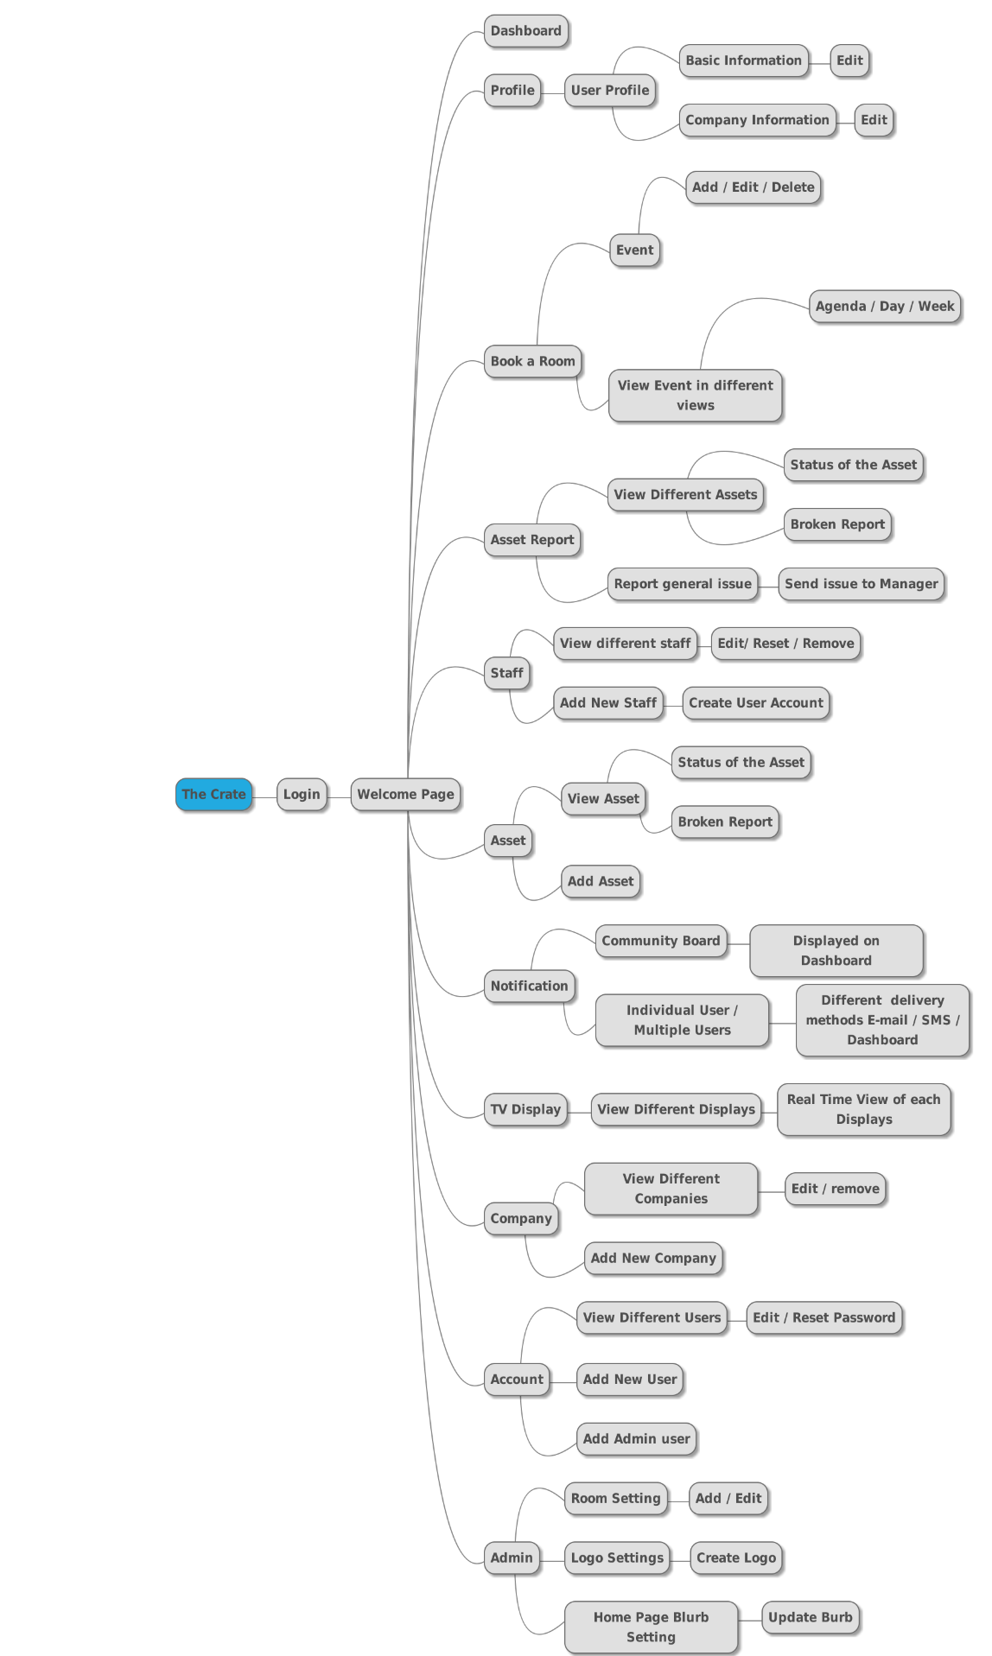

# Login Page

Launch the Url http://uat.thecrate.co.nz/Account/Login

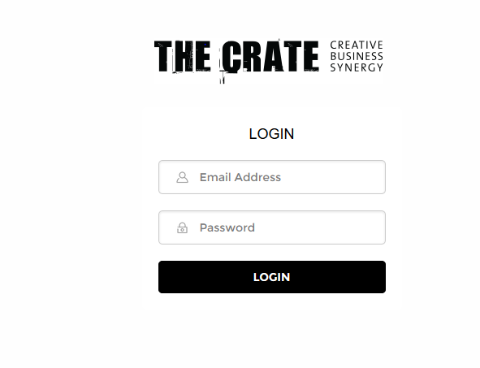

This Section of the document contains the following fields

|  |  |  |
| --- | --- | --- |
| Email Address | Textbox | Mandatory |
| Password | Textbox | Mandatory |
| Login | Button | Mandatory |

Validations:

* Validations should be displayed if mandatory fields are not entered
* Validations should be displayed for Entering Invalid Credentials

Business Rules:

* Clicking on Login with valid credentials should navigate the user to Welcome page.

## Welcome Page

Welcome Page contains the following top navigation menu bar

1. Dashboard
2. Profile
3. Book a room
4. Asset Report
5. Staff
6. Asset
7. Notification
8. TV display
9. Company
10. Account
11. Admin

# Dashboard

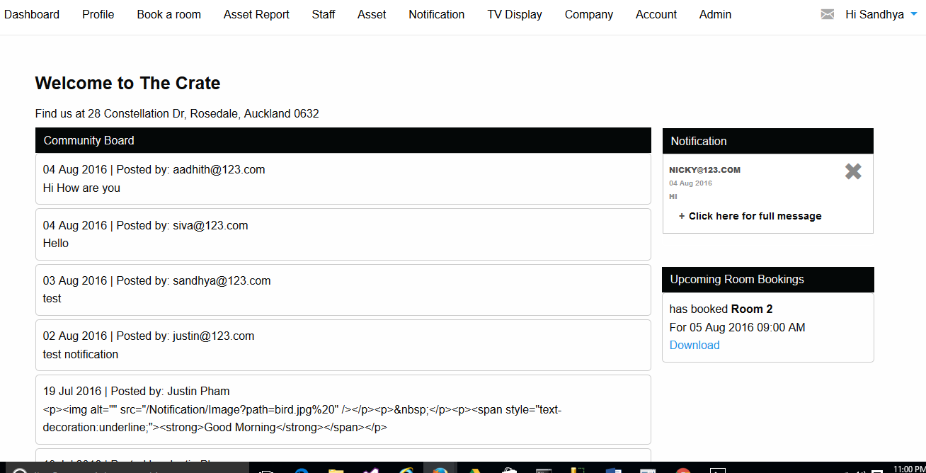

Dashboard displays the following details

1.Community board

2.Notification

3.Upcoming Room bookings

## Business Rules

* User posted ‘Notifications’ for ‘Community Board’ should be displayed on “Dashboard” “Community Board”
* User Posted “Notifications” for “individual user” should be displayed on “Dashboard ““Notifications”
* User Booked a Room in “Book A room” should be displayed on “Dashboard” “Upcoming Room Bookings”
* Bookings deleted on “Book A Room” page should be displayed on “Dashboard” “Upcoming Room Bookings”
* User “deleted” “Notifications” Should be displayed and updated

# Profile

Profile Consists of 1. Basic Information

2. Company Information

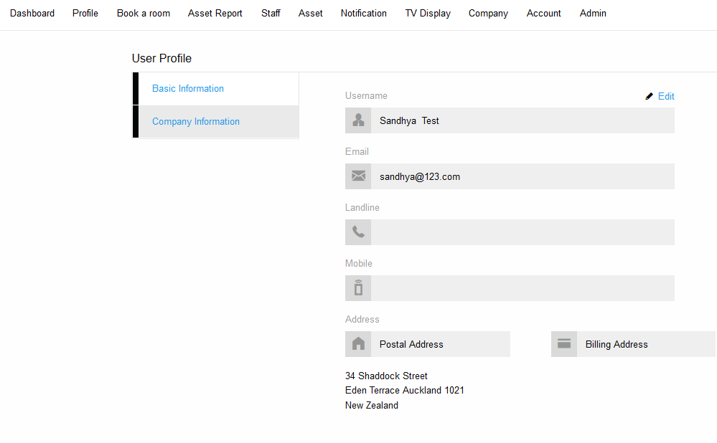

* Basic information Contains the following Fields with “Edit” link

1.UserName

2.Email

3.Landline

4.Mobile

5.Postal Address

6.Billing Address

* Edit link contains following fields

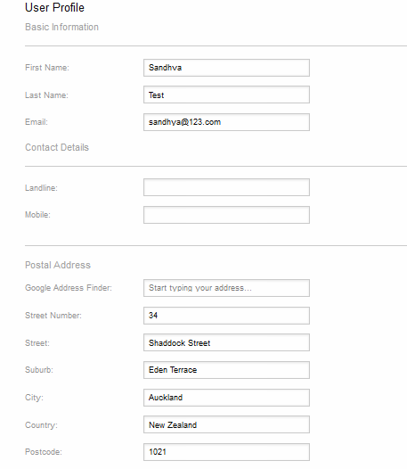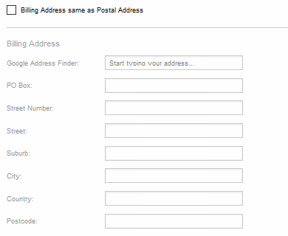



## Business Rules

* “Basic Information” on “User Profile” page should only be readable.
* “Basic Information” should be Editable
* Mandatory Fields left blank should be displayed with validations
* Basic information Edited should be updated and displayed on “User Profile” page

# Company Information:

Company details created in “Company” Page should be displayed in Company Information

Company Information Contains following fields with “Edit” link

1.Company Name

2.Company Contact

3.Landline

4.Mobile

5.Email

6. postal Address

7.billing Address

* Edit link Should display with a page to edit the details of the company

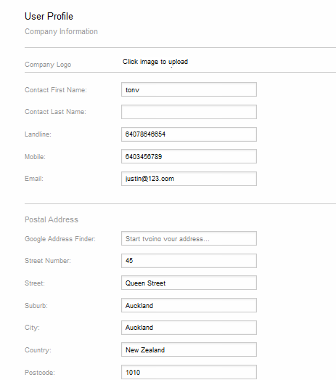 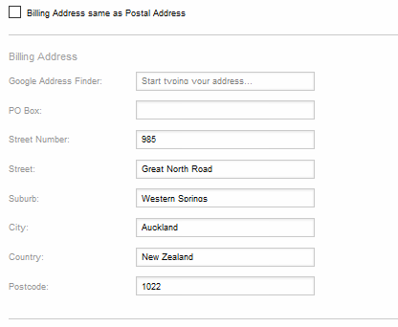

## Business Rules:

* “Company Information” displayed should be readable
* “Company Information” should be Editable
* “Company Information” Edited and Updated should be displayed on “User profile” Company information Page
* Mandatory fields left blank should throw validations.

# Book a Room

Clicking on Book a room on the top menu bar, will show a calendar with the existing details of bookings. Calendar also allows to Add/Edit/Delete booking details.

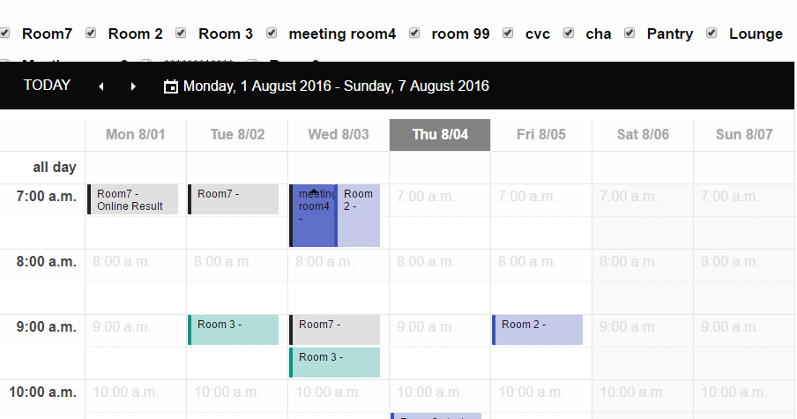

#### Event

Double click on any of the Date will allow the user to add new booking details.

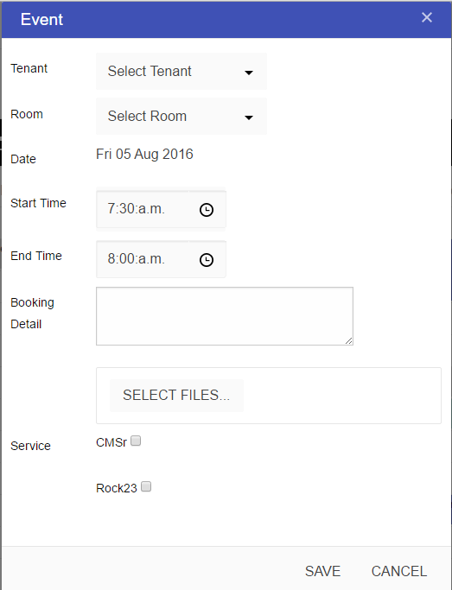

#### AGENDA

Clicking on Agenda on header bar will list the agenda for the current day.

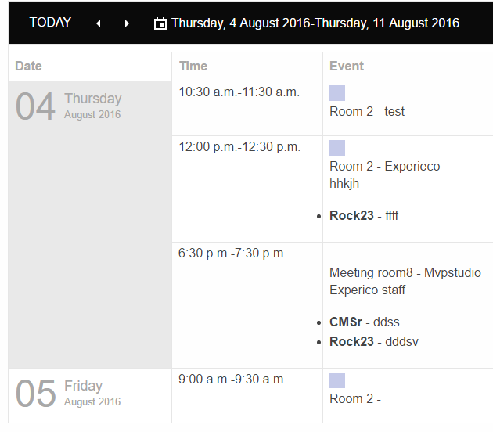

#### Day

On Clicking Day in the header bar user will be able to see the particular day and also have the option for Show business hours and also show full day

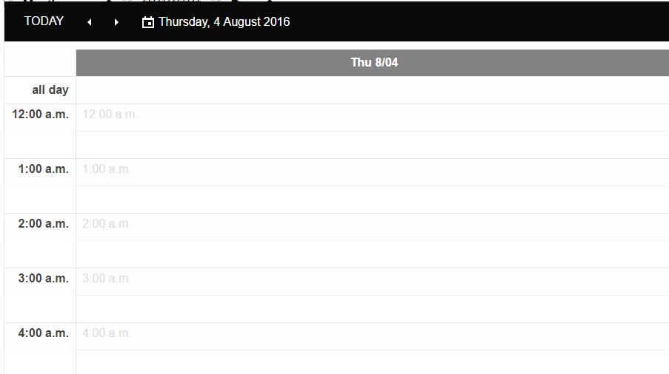

**Week**

On Clicking Week in header bar, user will be able to see the whole week and also have the option for Show business hours and also show full day

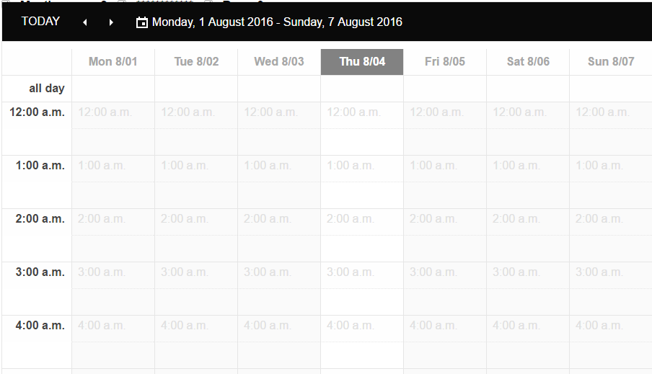

## Business Rules

* ‘Event’ popup window should let the user to select ’Tenant ’,’Room’ ,’Date ’,’Start Time ,’End Time’ ,’Booking Details’ ,’Select file’ and ‘service’ with the option to ‘Save and ‘Cancel’
* Today’s ‘Agenda’ should display time and event of the day
* Existing event of the day and events in week should display when user select ‘Day’ and ‘week’ respectively.
* User can select ‘rooms ‘ according to their choice by tick box

# Asset Report

On clicking on the ‘Asset Report’ on the top menu bar, the list of existing assets is displayed.

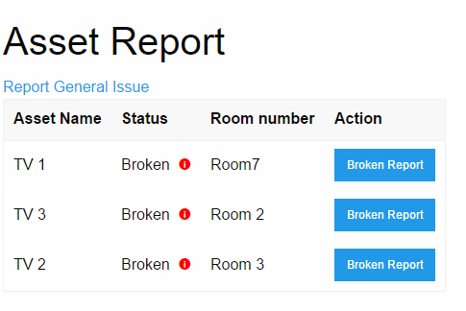

#### Report General Issue

On clicking the ‘Report General Issue’ hyperlink, the user can create an issue report to manager via Email

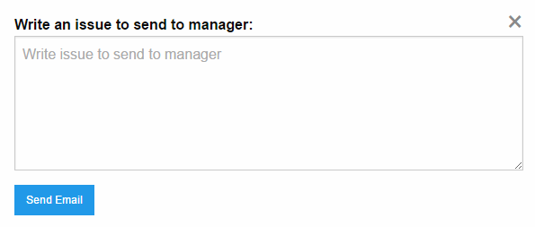

#### Broken Report

Broken Report contain the report of broken asset.

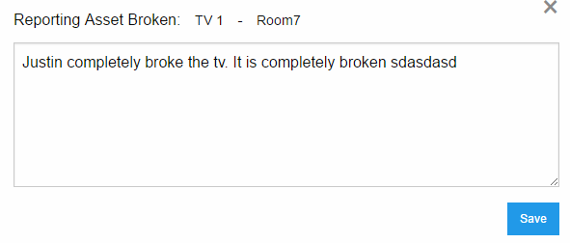

## Business Rules

* “Report General Issue’ hyperlink should let user to send an issue to manager via Email
* Existing assets should be visible when the user navigates to the Asset page
* Broken Report link should let the user view the details of broken with the option to save.

# Staff

On clicking ‘Staff’ the list of existing Staff with username, Full name, Email address and Action(Edit, Reset Or Remove) is displayed and also have the options to ‘Add new staff’

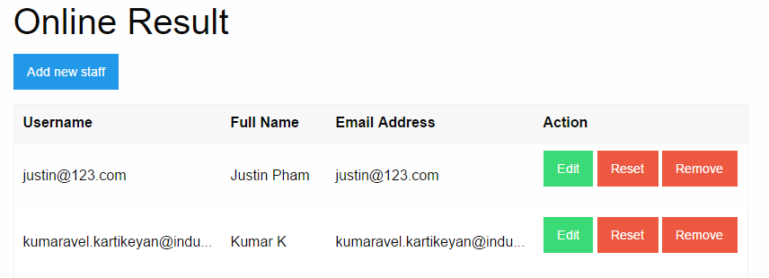

#### Add new staff

On clicking on ‘Add new staff’ allows user to create new staff

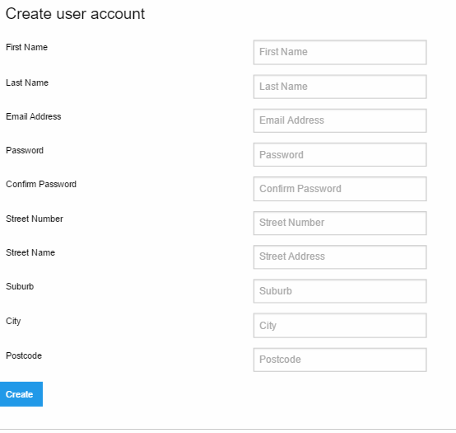

## Business Rules

* ‘Add new staff’ let the user to create a new staff with mandatory fields such as First Name ,Last Name ,Email address ,password ,confirm password ,street number ,street name ,suburb ,city and postcode asset.
* Existing staff should be visible when the user navigates to the staff page with the options of Edit ,Reset and Remove

# Asset

On clicking on the ‘Asset’ button on the top menu bar, the list of existing assets is displayed.

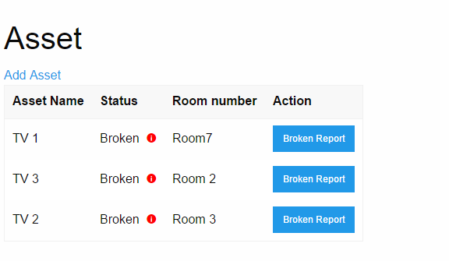

#### Add Asset

The admin can ‘add asset’ (new) by Asset Type, Name, Mac Address and Room

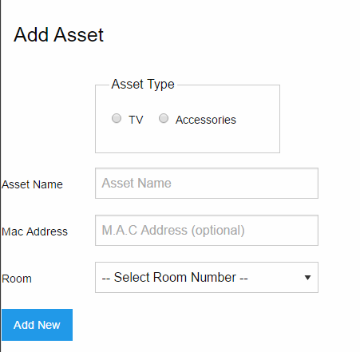

#### Broken Report

‘Broken Report’ contain the report of broken asset.

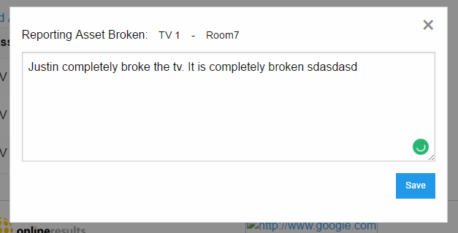

## Business Rules

* Asset option should only be available to admin user.
* ‘Add Asset’ hyperlink should let the user to add a new asset.
* ‘Add Asset’ link should have the mandatory fields such as Asset Type, Asset Name and the Room, Mac Address is not mandatory. With this information user should be able to add new details
* Existing assets should be visible when the user navigates to the Asset page
* Broken Report link should let the user view the details of broken with the option to save.

# Notification

On clicking the ‘Notification’ hyperlink on the top menu, the user can create notification for community board / individual user.

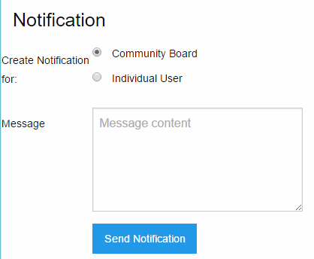

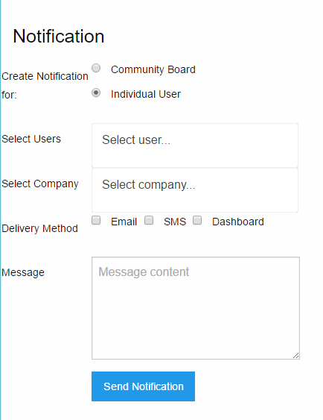

## Business Rules

* Notification feature is only available to the admin
* User should be able to create notification for ‘community board’ and ‘individual users’.
* The community Board notification should be displayed in the ‘Dashboard’.
* The individual notification should be able to send to multiple users in a company with different delivery method like E-mail, SMS, Dashboard.

# TV Display

On clicking the ‘TV Display’, different TV available are displayed. 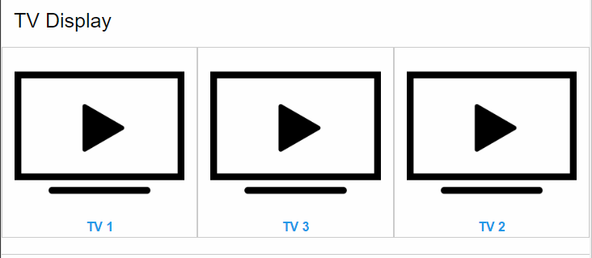

On clicking the TV1, the content that is currently live is shown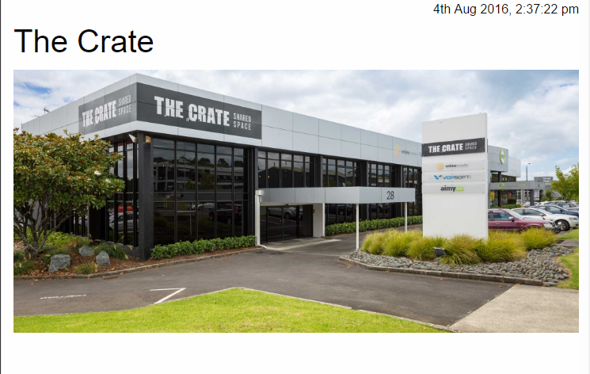

## Business Rules

* TV Display should only be available to admin user.
* Different TV Display should be displayed when clicking the ‘TV Display’.
* Each TV Display’s content should be live when clicked on the corresponding TV (for eg: On clicking theTV1, it should display the contents that are currently live on that portal.)

# Company

By Clicking on the “Company” menu bar navigates to the “Company Management “page.

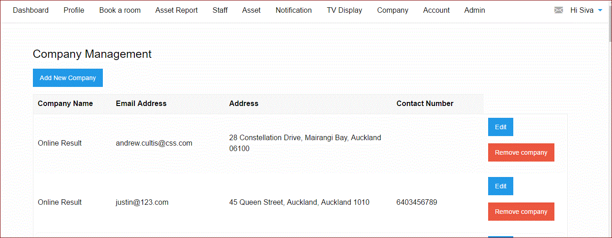

#### Add New Company

By clicking on the “Add New Company” button in the “Company Management” page navigates to the following page

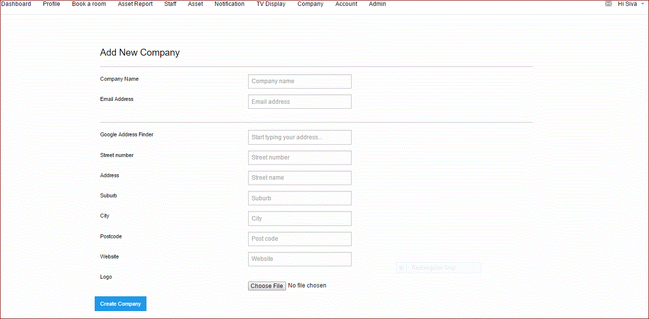

#### Edit

By clicking on the “Edit” button in the “Company Management” page navigates to the following page.

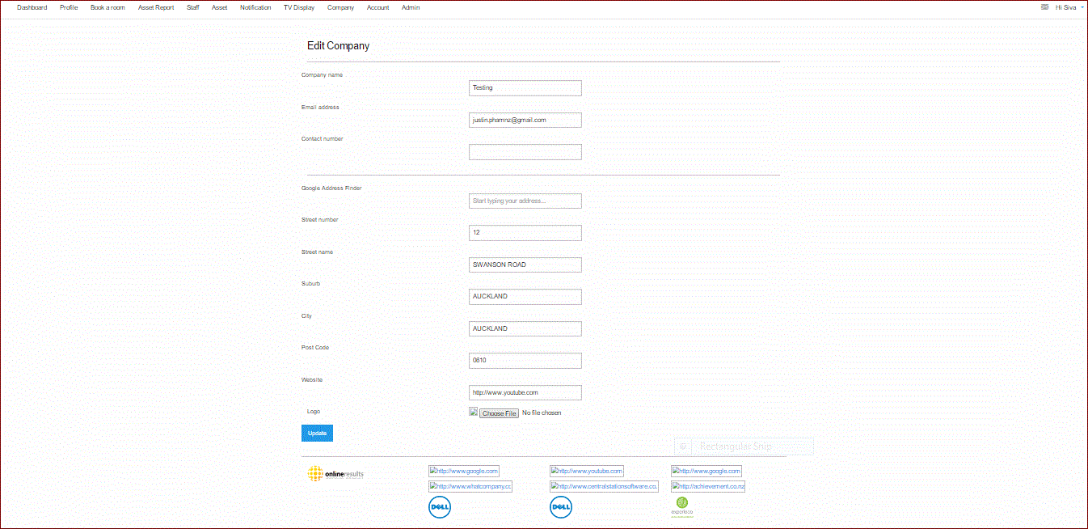

#### Remove Company

By clicking on the “Remove Company” button, in the “Company Management” page, you get the Popup window

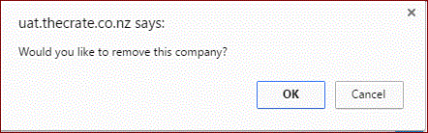

* By Clicking on the “OK” button the selected company gets deleted.
* By Clicking on the “Cancel” button navigates back to the “Company Management” page.

## Business Rule

* User should view “Add New Company” button under the text “Company Management” on the left hand side of the page
* User should view four column headers as

1. Company Name

2. Email Address

3. Address

4. Contact Number

* User should view all the records created under the Column names.
* User should view “Edit” and “Remove Company” buttons on the right hand side of the page.
* By clicking on the “Create New Company” button, user should be able to create a New Company along with the “Logo”
* Entering the data in the “Text boxes” for the field names and clicking on the “Create Company “button, user should be able to create a company
* Clicking on the “Choose file” button, user should be able to upload the “Company Logo”
* Should allow user to make changes for the selected company
* By clicking on the “Update” button in the “Edit Company” page user should navigate to the “Company management” page

# Accounts

By Clicking on the “Accounts” menu bar navigates to the “Account Management “page

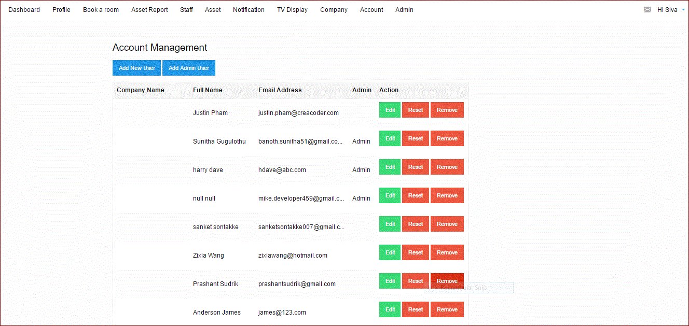

#### Add New User

By clicking on the “Add New User” button in the “Account Management “page navigates to the following page.

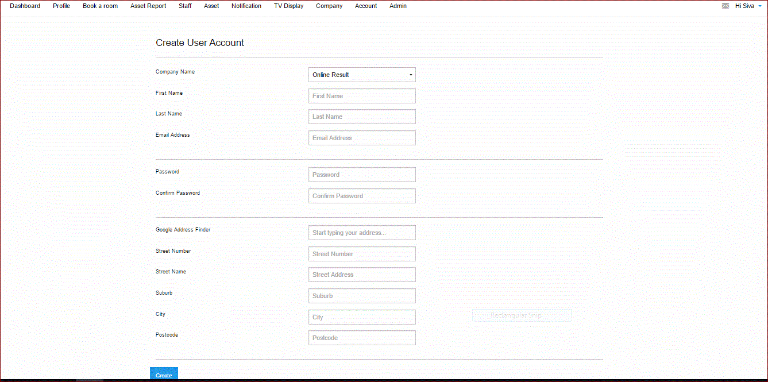

#### Create

Clicking on the “Create” button should get the popup window “New User” created

#### Add Admin User

By clicking on the “Add Admin User” button in the “Account Management “page navigates to the following page.

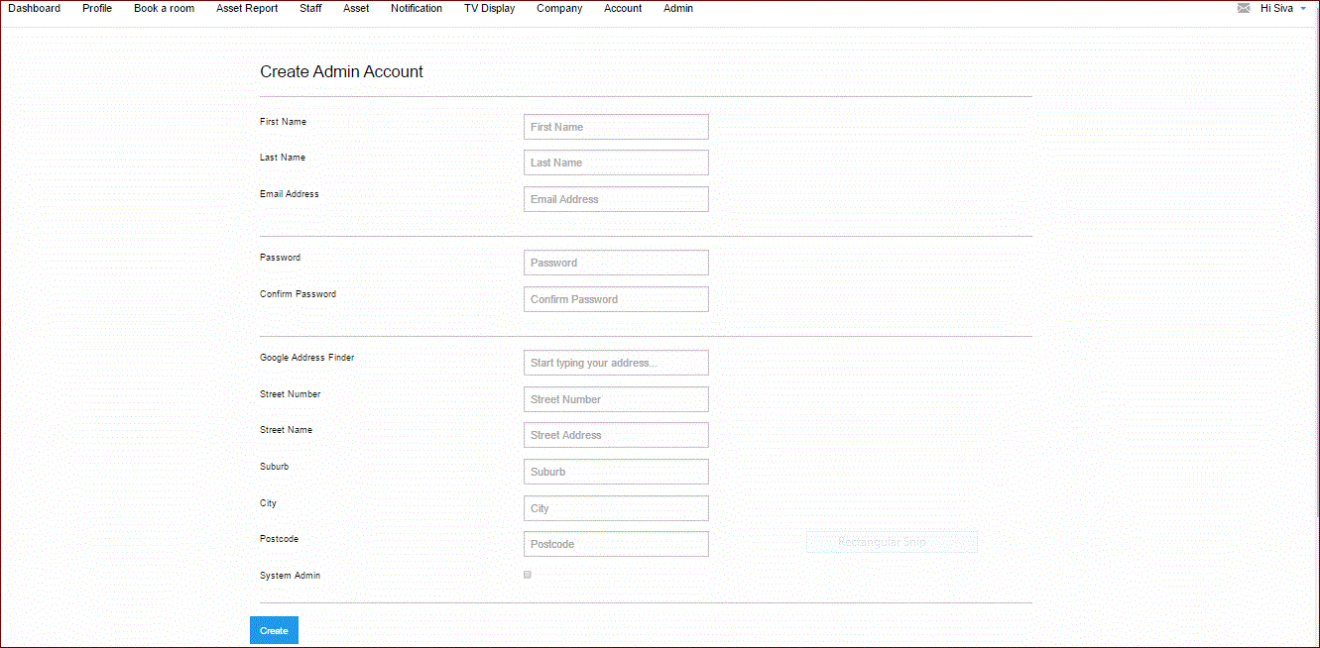

#### Create

Clicking on the “Create” button should get the popup window “New Admin User” created

#### Edit

By clicking on the “Edit” button in the “Account Management” page navigates to the following page

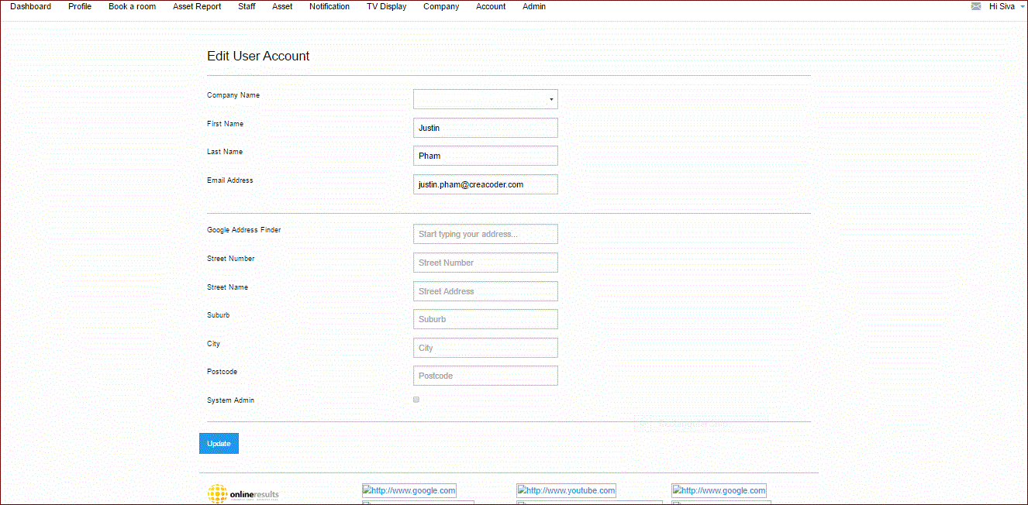

#### Reset

By clicking on the “Reset” button in the “Account Management” should get a popup window

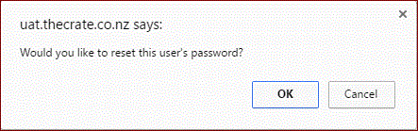

By clicking on the “OK” button in the “Popup window” should get the following popup window

Reset pwd confirmation

#### Remove

By clicking on the “Remove” button in the “Account Management” should get a popup window

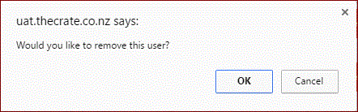

* By Clicking on the “OK” button should be able to delete the user from the ”Account Management” page.

## Business Rule

* By clicking on “Add new User” button user should be able to select the created company from the dropdown
* User should be able to enter the data in the textboxes for the given field names in the “Create Account Page”
* By clicking on the “create” button should be able to create a new user
* By clicking on “Add Admin User” button user should be able to select the created company from the dropdown
* User should be able to enter the data in the textboxes for the given field names in the “Create Account Page”
* User should select the “System Admin” Checkbox while creating an Admin user
* By clicking on the “create” button should be able to create a new user
* Should allow user to make changes for the selected company
* By clicking on the “Update” button in the “Edit Company” page user should navigate to the “Company management” page.

Admin

By Clicking on the “Admin” menu bar navigates to the “Settings “page

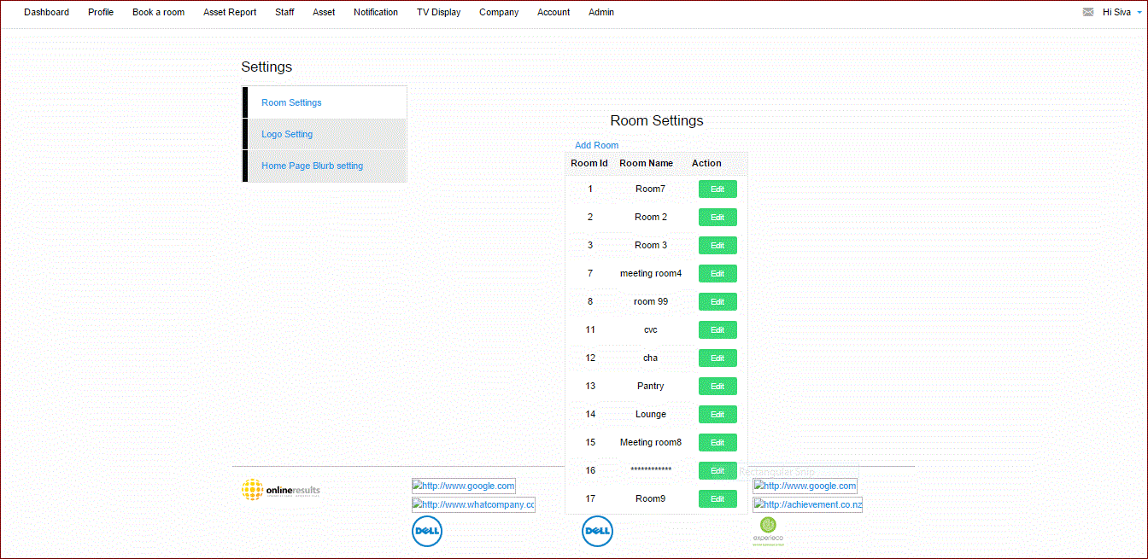

# 

#### Add a Room

By Clicking on the “Add Room” hyperlink under the text “Settings”, navigates to the following page

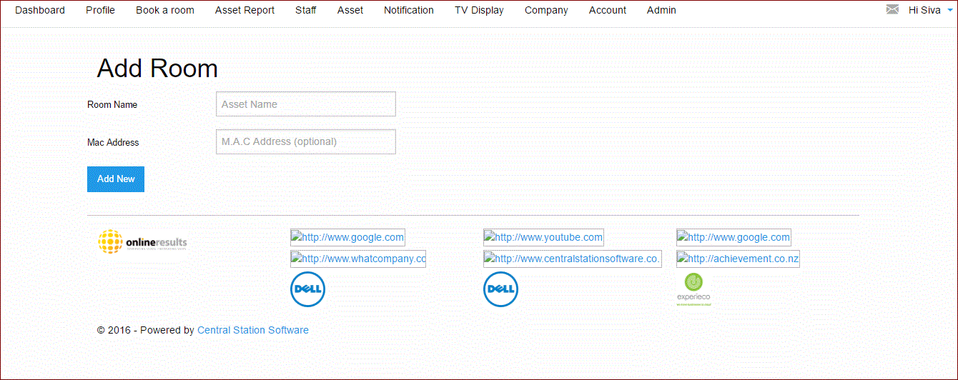

#### Edit

By Clicking on the “Edit” button, under the text “Room Settings”, navigates to the following page

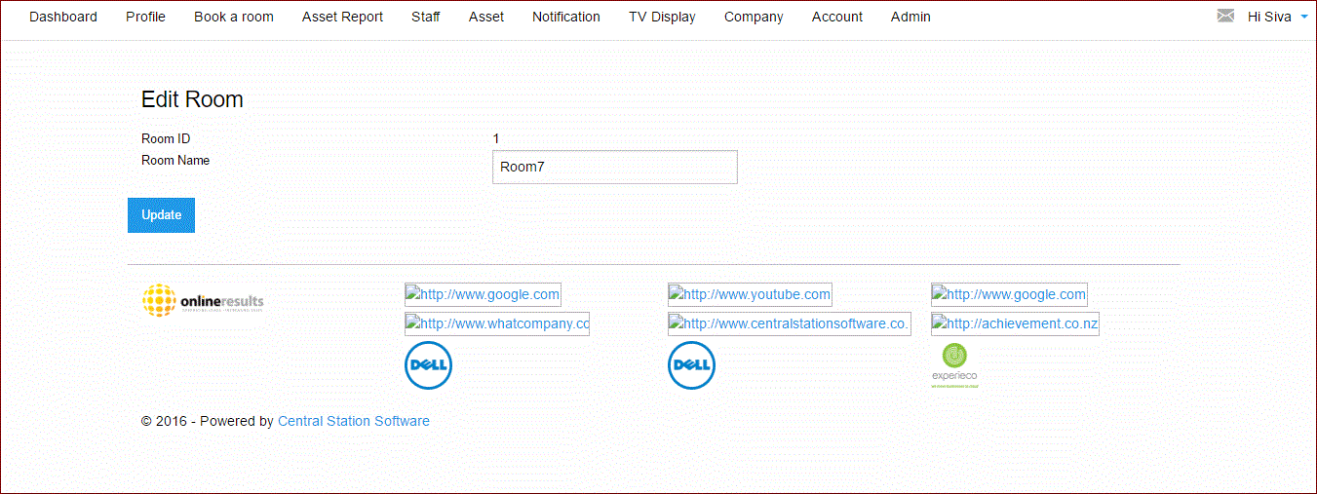

## Business Rule

* By clicking on “Admin” form the menu bar user should navigate to the “Settings” page
* User should be able to view three hyperlinks under the text “Settings” on the left hand side

1. Room Settings

2. Logo Setting

3. Home Page Blurb settings

* User should view the text as “Room Settings” on the right hand side of the page
* User should view a hyperlink as “Add Room” under the text “Room Settings”
* User should view three column headers under the “Add Room” hyperlink as

1. Room Id

2. Room Name

3. Action

* User should be able to view all the created rooms under the column headers.
* User should be able to view “Edit” button besides the “Rooms Created” on the right hand side of the page.
* User should be able to create a room entering the data in the textboxes for the given field names in the “Add Room” page
* By Clicking on “**Add New**” button in the ”Add Room” page room gets created and user should navigate back to the previous page and be able to see the room created.
* User should be able to view the selected room with the text as “Edit Room”
* User should be able to view to Field names under the text “Edit Room” as
* 1.Room ID
* 2.Room Name
* User should be able to make changes in the text box for the field name” Room Name”
* **Clicking on the “Update” button in the “Edit Room” page , should be able to modify the changes and navigate back to the previous page.**

#### Logo Setting

By clicking on the “Logo setting” hyperlink in the “Settings “page, navigates to the following page

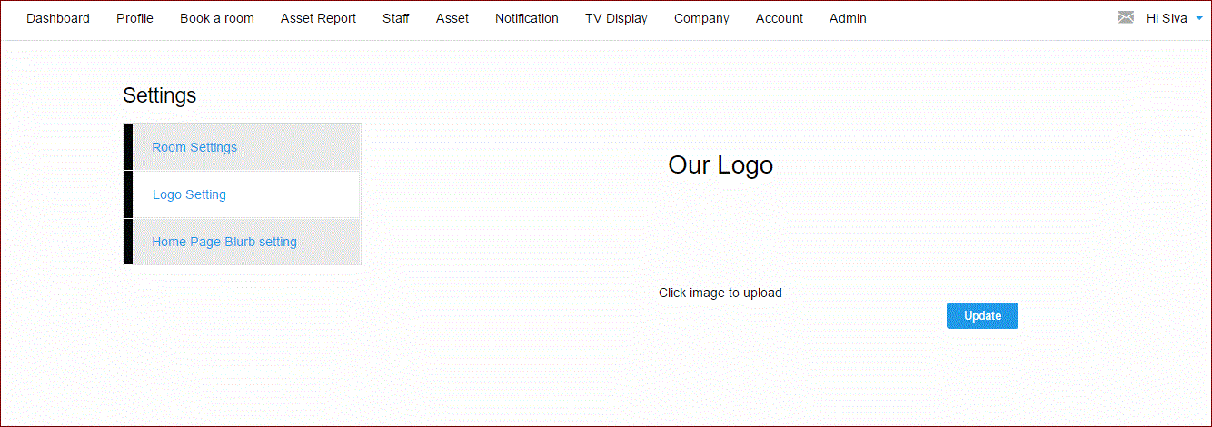

##### Business Rule

* User should view all the three hyperlinks with the “Logo setting” hyperlink highlighted under the text “Settings” on the left hand side.
* User should view the text as “Logo” in bold on the right hand side.
* User should view a hyper link as “Click image to upload” under the text “Logo”, were user can upload an image for the creation of the company.
* By clicking on the “Update” button should be able to upload a image and navigate back to the previous page.

#### Home page Blurb Setting

By clicking on the “Home page Blurb Setting” hyperlink in the “Settings “page, navigates to the following page

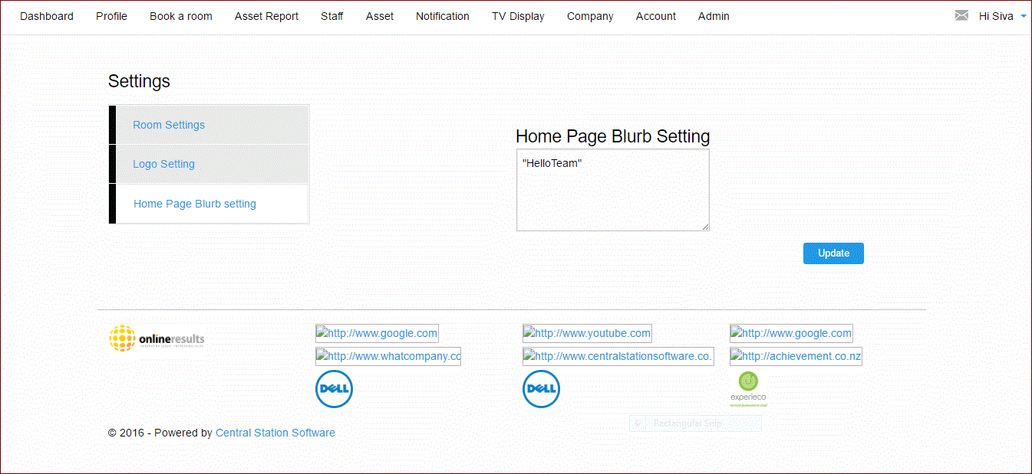

##### Business Rule

* User should view all the three hyperlinks with the “Home Page Blurb setting” hyperlink highlighted under the text “Settings” on the left hand side.
* User should view the text as “Home Page Blurb setting” in bold on the right hand side.
* User should view a “Square box” to enter the comment/Text, were user can view in the Dashboard.
* By Clicking on the “Update” button should be able to update the “Text” in the “Dashboard” page and navigate back to the previous page.